Style Guidelines for Final Year Project ReportsTailorMe

Final Year Project – Mid Report

Session 2021-2025

A 4th Year Student

A project submitted in partial fulfilment of the

COMSATS University Degree

of

BSc. (Hons.)BS in Computer Science / Software Engineering (CUI)



Department of Computer Science

COMSATS University Islamabad, Lahore Campus

16 December 2024

# Project Detail

|  |  |  |  |  |  |
| --- | --- | --- | --- | --- | --- |
| Type (Nature of project) | | | [✓] **Development**  [ ] **Research** & **Development** | | |
| Area of specialization | | | Digital Image Processing & Computer Vision | | |
| **Project Group Members** | | | | | |
| Sr.# | Reg. # | Student Name | | Email ID | *Signature |
| (i) | FA21-BCS-006 | Muhammad Ali | | MuhammadAli.16k@gmail.com |  |
| (ii) | FA21-BCS-066 | Muhammad Yaqoob | | yaqoobk960960@gmail.com |  |
| (iii) |  |  | |  |  |

*The candidates confirm that the work submitted is their own and appropriate credit has been given where reference has been made to the work of others

# Plagiarism Free Certificate

This is to certify that, I am ________________________ S/D/o _______________________, group leader of FYP under registration no CIIT/_________________/LHR at Computer Science Department, COMSATS University Islamabad, Lahore Campus. I declare that my FYP report is checked by my supervisor and the similarity index is ________% that is less than 20%, an acceptable limit by HEC. Report is attached herewith as Appendix A.

Date: ____________ Name of Group Leader: ________________________ Signature: _____________

Name of Supervisor: _____________________ Co-Supervisor (if any):____________________

Designation: _____________________ Designation: _____________________

Signature: _____________________ Signature: _____________________

**Abstract**

Clothing measurements, particularly for tailored garments, often require precise and efficient methods, which is usually done through manual measurements and this requires being physically present at the shopping venue and the availability of measuring tools such as a measuring tape.  
  
Hence we have proposed TailorMe, a body measurement application, that aims to address this issue by leveraging image processing techniques. The application processes user-uploaded images to measure body dimensions such as neck, waist, shoulders, chest, height, and arm length.   
  
Our goal is to create a user-friendly application that enables users to take or upload images, receive their measurements, and obtain clothing size recommendations. We also want to accommodate desi (South Asian) and western clothing preferences and provide classifications for different user categories (children and adults), ensuring inclusivity.

We hope to offer a practical solution to simplify the tailoring process and reduce the number of returns that happen during online shopping because of mismatched sizes.

Content

1 Introduction 10

1.1 Introduction 10

1.2 Objectives 10

1.3 Problem statement 10

1.4 Assumptions & constraints 11

1.4.1 Assumptions 11

1.4.2 Constraints 11

1.5 Project scope 11

1.5.1 What to Consider 11

1.5.2 What to not Consider 11

2 Requirement Analysis 12

2.1 Literature review / Existing system study 12

2.2 Stakeholders list (Actors) 13

2.2.1 Primary Stakeholders: 13

2.2.2 Secondary Stakeholders: 13

2.3 Requirements elicitation 13

2.3.1 Functional requirements 13

2.3.2 Non-functional requirements 15

2.4 Requirements traceability matric 16

2.5 Use case descriptions 19

2.5.1 UC01 - User Registration 19

2.5.2 UC02 - User Login 19

2.5.3 UC03 - Reset Password 20

2.5.4 UC04 - Review Past Measurements 20

2.5.5 UC05 – Image Upload & Measurement Extraction 21

2.5.6 UC06 – Image Capturing Using Phone Camera & Measurement Extraction 21

2.5.7 UC07 – Clothing Size Recommendation 22

2.6 Use case design 23

2.6.1 User Sign-Up and Login 23

2.6.2 Profile Management 24

2.6.3 Image Uploading and Measurement 25

2.6.4 Image Capturing 26

2.6.5 Clothing Size Recommendations 27

2.7 Software development life cycle model 28

3 System Design 29

3.1 Work breakdown structure (WBS) 29

3.2 Activity diagram 30

3.2.1 AD01 – Signup 30

3.2.2 AD02 – Login 31

3.2.3 AD03 – Uploading an Existing Photo 32

3.2.4 AD04 – Taking a Photo for Measurement 33

3.2.5 AD05 – Getting Clothing Size Recommendation 34

3.2.6 AD06 – History of Past Measurements & Clothing Size Recommendations 35

3.2.7 AD07 – Database management 36

3.3 Sequence diagram 37

3.3.1 SD01 – Sign up 37

3.3.2 SD02 – Login 37

3.3.3 SD03 – Taking a Photo for measurement 38

3.3.4 SD04 – Uploading Photo for measurement 38

3.3.5 SD05 – Clothing Size Recommendation 39

3.3.6 SD06 – User Feedback 39

3.4 Software architecture 40

3.5 Class diagram 41

3.6 Database diagram 41

3.7 Network diagram (Gantt chart) 42

3.7.1 Network diagram 42

3.7.2 Gantt Chart 42

3.8 Collaboration diagram 43

3.8.1 Login 43

3.8.2 Reset Password 43

3.8.3 Upload Picture for Measurement 44

3.8.4 Take Picture for Measurement 44

3.8.5 Clothing Size Recommendation 45

3.8.6 Get History of Past Measurements and Recommendations 45

4 System Testing 46

4.1 Test cases 46

4.1.1 Login 46

4.1.2 Update Profile 46

4.1.3 Reset Password 47

4.1.4 User Interface 47

4.1.5 View Past Measurements and Clothing Size Recommendations 48

4.1.6 Image Upload 49

4.1.7 Image Validation 49

4.1.8 Image Capture 50

4.1.9 Measurement Extraction 50

4.1.10 Manual Measurement Adjustment 51

4.1.11 Clothing Size Recommendation 52

4.1.12 Database Management 53

4.2 Unit 53

4.3 Integration 53

4.4 Acceptance testing 54

5 Conclusion 54

5.1 Problems faced and lessons learned 54

5.2 Project summary 54

5.3 Future work 55

5.3.1 Enhance Features 55

5.3.2 Platform Expansion 55

5.3.3 Scalability 55

6 References 55

**List of Tables**

Table 1 Literature review sources 1

**List of Figures**

Figure 1 Selecting the Heading 1 style from the Word style menu. 7

# Introduction

## Introduction

Clothing measurements are a crucial aspect of tailoring and garment shopping, yet many individuals struggle with obtaining precise and consistent body measurements. This is particularly challenging when tailoring traditional or custom-made clothing, where accurate measurements are essential for a proper fit. To address this issue, we propose **TailorMe**, a body measurement application that utilizes image processing techniques to provide users with accurate and efficient measurements.

**This app** aims to change how people measure their body dimensions by introducing a simple and user-friendly platform that leverages technology. Using a smartphone camera, users can take or upload photos, which are processed to extract key measurements such as neck size, waist, shoulders, chest, height, and arm length. The application also recommends clothing sizes based on these measurements, catering to both desi and western clothing preferences.

The backend of **the app**, built with Python and powered by libraries like OpenCV, handles image processing and measurement extraction. The frontend, designed in React Native, provides users with an intuitive interface to interact with the app. By integrating advanced image analysis techniques, the app ensures inclusivity by accommodating children and adults and offering gender-specific sizing recommendations. This innovative approach reduces dependency on manual measurements, saving time and effort for users while ensuring accuracy.

This introduction provides a foundation for this project, outlining its objectives and scope while highlighting its potential to simplify tailoring and garment shopping experiences for users worldwide.

## Objectives

• Provide reliable body measurements using image processing techniques.

• Offer sizing recommendations for desi and western clothing.

• Create a user-friendly application for taking and uploading images for measurements.

• Reduce dependency on manual measurement methods.

## Problem statement

Accurate body measurements are essential for tailored clothing and garment shopping, yet traditional manual methods are prone to errors and inconsistencies. This often results in ill-fitting garments and a time-consuming tailoring process. Additionally, there is no accessible tool for users to measure their bodies accurately using their smartphones. The absence of such a tool limits the ability to quickly obtain precise measurements for various clothing types, especially for desi attire where standard size charts may not suffice. This highlights the need for an innovative solution to simplify the measurement process and ensure accuracy in clothing fit.

## Assumptions & constraints

### Assumptions

* Users will upload clear and well-lit images for accurate measurements.
* Smartphones with cameras are widely available for app users.
* Measurement results will comply with standard size recommendations.
* Privacy and security of user images and data will be maintained.

### Constraints

* Image quality directly affects measurement accuracy.
* The app must function efficiently on resource-limited devices.
* Limited time for development and testing phases.
* Ensuring compatibility across diverse body shapes and sizes.

## Project scope

### What to Consider

* Development of a backend for image processing and measurement extraction using Python.
* React Native frontend for a seamless user interface.
* Support for different clothing styles (desi and western).
* Integration of security measures for image data storage and processing.

### What to not Consider

* Advanced AI features like predictive sizing beyond measurements.
* Integration with third-party clothing brands for virtual try-ons.
* Detailed customization options for niche clothing types.  
  Extensions beyond core functionality like body posture analysis.

# Requirement Analysis

We identify the requirements here and give a brief description of them in a conclusive way.

## Literature review / Existing system study

Various research and development efforts have been made in body measurement extraction. Previous work includes techniques in computer vision, such as contour detection and key-point estimation using libraries like **OpenPose** 1.

During our research we came across apps like **MirrorSize** 2, which uses AI for body measurements. **3DLOOK** 3**,** an app that captures over 80 points of measurement using just two photos taken by the user. **Bodymapp** 4**,** a3D body scanning app that allows users to measure and track their body composition and circumference measurements using an iPhone X or above.

We also came across the following Studies and research papers:

1. A Review of Body Measurement Using 3D Scanning 5: <https://www.researchgate.net/publication/351207865_A_Review_of_Body_Measurement_Using_3D_Scanning>
2. This study focused on estimating upper body dimensions using a single RGB camera, such as those found on smartphones. The process involved several steps, including image calibration and feature extraction, to accurately derive body measurements 6: <https://www.semanticscholar.org/paper/Measuring-the-Human-Body-from-a-Single-Camera%2C-with-Montazerian-LEYMARIE/ae8c70ec2e5fe71f7692f51a9f7527f173d46f41?utm_source=direct_link>
3. Designing a Contactless, AI System to Measure the Human Body using a Single Camera for the Clothing and Fashion Industry – University of London 7:  
   <https://www.researchgate.net/publication/373343443_Designing_a_Contactless_AI_System_to_Measure_the_Human_Body_using_a_Single_Camera_for_the_Clothing_and_Fashion_Industry>
4. Automatic Extraction of 3D Body Measurements from 2D Images: This paper proposes an automated system that extracts body measurements from 2D images, facilitating better garment fitting for small businesses. The system was tested on images of young females, comparing the results with manual measurements to validate its accuracy 8~ <https://www.semanticscholar.org/paper/Automatic-Extraction-of-3-d-Body-Measurements-from-Sehgal-Gupta/d49108ddfdeb2ddf973589bb078000274ee7fb01>

## Stakeholders list (Actors)

### Primary Stakeholders:

* End Users: Individuals seeking tailored clothing or size recommendations.

### Secondary Stakeholders:

* Developers: Building and maintaining the application.
* Retailers: Potential future integration for online shopping.
* Tailors and Designers: Utilize accurate measurements for better results.

## Requirements elicitation

### Functional requirements

#### FR01 – User Management

|  |  |
| --- | --- |
| FR01 - 01 | **User Registration:** User should be able to create their profile on the application |
| FR01 - 02 | **User Login:** User should be to login using their credentials. (Username/Email and Password). |
| FR01 - 03 | **Profile Management:** Users should be able to update and manage their profile information. |
| FR01 – 04 | **Measurement History:** Allow users to view past measurements and recommendations. |

#### FR02 - User Interface

|  |  |
| --- | --- |
| FR02 – 01 | The User interface should be an intuitive interface for easy navigation. |

#### FR03 - Image Upload

|  |  |
| --- | --- |
| FR03 - 01 | The user should be allowed to upload images for measurement. |

#### FR04 - Image Validation

|  |  |
| --- | --- |
| FR04 - 01 | The user uploaded images should be validated for resolution and pose requirements. |

#### FR05 – Capturing Image using Phone Camera

|  |  |
| --- | --- |
| FR05 - 01 | The Users phone camera must be calibrated properly to take correct images for measurement extraction. |
| FR05 - 02 | The User shall be able to capture image through the apps camera interface. |

#### FR06 - Measurement Extraction

|  |  |
| --- | --- |
| FR06 - 01 | Ensuring the measurements have minimum error. |

#### FR07 - Measurement Adjustments

|  |  |
| --- | --- |
| FR07 - 01 | Enable users to manually adjust measurements manually if needed. |

#### FR08 - Clothing Recommendations

|  |  |
| --- | --- |
| FR08 - 01 | **Clothing Type Selection:** Allow users to select the type of clothing (e.g., casual, formal, traditional/desi). |
| FR08 – 02 | **User Classification:** Classify Users. For example by age/gender. |
| FR08 – 03 | **Size Recommendation:** Suggest sizes based on extracted measurements and clothing type |

#### FR09 - Backend Database

|  |  |
| --- | --- |
| FR09 - 01 | **Data Storage:** The system will Store user data, measurements, and preferences securely. |

### Non-functional requirements

NFR01 - System Performance

|  |  |
| --- | --- |
| NFR01 - 01 | Ensure that the app responds to the user within reasonable time. |

NFR02 - Scalability

|  |  |
| --- | --- |
| NFR02 – 01 | The app will be designed so that it can be scaled horizontally, to handle increasing user loads |
| NFR02 – 01 | In terms of system architecture, we must make sure the app can accommodate future work. |

NFR03 - Reliability

|  |  |
| --- | --- |
| NFR03 - 01 | The app should be highly available in terms of reliability. It should have minimal downtime and system failures. |

NFR04 – Usability

|  |  |
| --- | --- |
| NFR04 - 01 | The app should have an intuitive interface that requires minimal learning for new users. |

NFR05 – Security

|  |  |
| --- | --- |
| NFR05 – 01 | The app that we will develop should implement robust security measures to protect user data that the user will provide us, including encryption of sensitive information of our user, secure authentication mechanisms, and protection against common security threats |

NFR06 - Legal and Ethical

|  |  |
| --- | --- |
| NFR06 - 01 | Adhere to intellectual property rights and avoid unauthorized use of third-party assets. |
| NF06 – 02 | Ensure the app’s algorithms do not discriminate based on gender, age, or other personal attributes. |

NFR07 – Feedback

|  |  |
| --- | --- |
| NFR07 - 01 | Allow users to provide Feedback. |

## Requirements traceability matric

This table shows the functional requirements traceability matrix of our project gives the reference of use case description, activity diagram, sequence diagrams and test cases for all the functional requirements.

|  |  |  |  |  |  |  |
| --- | --- | --- | --- | --- | --- | --- |
| Functional Requirement Number | Functional Requirement Description | Use Case Description Number | Activity Diagram Number | Sequence Diagram Number | Collaboration Diagram Number | Test Case Number |
| FR01 | User management encompasses all functionalities related to creating and maintaining user accounts. Users should be able to register, log in, and manage their profile. Users should be able to access and review their past measurement history and recommendations. | UC01  UC02  UC03  UC04 | AD01  AD02  AD06 | SD01  SD02 | CD01  CD02  CD06 | TC01  TC02  TC03  TC04  TC07 |
| FR02 | The user interface should be designed to ensure an intuitive and seamless experience. | - | - | - | - | TC05  TC06 |
| FR03 | The image upload functionality provides users the option to upload an image from their phone gallery for measurement extraction. | UC05 | AD03 | SD04 | CD03 | TC08 |
| FR04 | Image validation ensures that uploaded photos meet the necessary requirements for successful measurement extraction. Factors such as resolution, lighting and background are checked to ensure the image is valid for further processing and measurement extraction. | - | - | - | - | TC09 |
| FR05 | This functionality allows users to capture images directly through the app using their phone camera. The camera must be calibrated first, and app should provide an interface that guides the user to take suitable photos for measurement extraction. | UC06 | AD04 | SD03 | CD04 | TC10 |
| FR06 | Measurement extraction focuses on accurately analyses the user’s uploaded or captured photos to derive key body measurements. The system must ensure minimal error during this process. | UC05  UC06 | AD03  AD04 | SD03  SD04 | CD03  CD04 | TC11 |
| FR07 | This functionality allows users to manually adjust their extracted measurements if necessary. | - | - | - | - | TC12 |
| FR08 | The clothing recommendation system provides users with personalized size suggestions based on their measurements. And preferred clothing type. | UC07 | AD05 | SD05 | CD05 | TC13 |
| FR09 | The backend database is responsible for securely storing user data, measurements, and preferences. It ensures privacy of user information. | - | AD07 | - | - | TC14 |

## Use case descriptions

### UC01 - User Registration

|  |  |
| --- | --- |
| **Use Case Name:** | User Registration |
| **Actors:** | User |
| **Description:** | User enters their credentials in the registration screen. They will input their chosen Username, Email and Password. |
| **Pre-Condition:** | * The app must be operational * The user shall not have another account with the same email |
| **Post-Condition:** | * The app confirms the new account was created |
| **Normal Flow of Event** | * User Opens the app. * Clicks on sign-up button. * Enters credentials. * The system validates the user’s information. * A new accounted is created. |

### UC02 - User Login

|  |  |
| --- | --- |
| **Use Case Name:** | User Login |
| **Actors:** | User, Admin |
| **Description:** | User and Admin |
| **Pre-Condition:** | * App must be operational * User must have an account. |
| **Post-Condition:** | * User / Admin are logged in. |
| **Normal Flow of Event** | * User opens the app. * Enters their credentials on the login screen. * The system validates the user. * User is now logged into the app with their account. |

### UC03 - Reset Password

|  |  |
| --- | --- |
| **Use Case Name:** | Reset Password |
| **Actors:** | User |
| **Description:** | User resets their password |
| **Pre-Condition:** | * App must be operational * User has forgotten their password. |
| **Post-Condition:** | * User has a new password, which they can use to login. |
| **Normal Flow of Event** | * The user opens the app. * Clicks on forgot password in the login screen. * User enters their Email. * System sends a password reset link to their email address. * User clicks on the link and sets a new password. * User can login with the new password. |

### UC04 - Review Past Measurements

|  |  |
| --- | --- |
| **Use Case Name:** | Review Past Measurements |
| **Actors:** | User |
| **Description:** | User shall be able to see the history of their past measurements from their profile page. |
| **Pre-Condition:** | * App must be operational. * User must be logged in. |
| **Post-Condition:** | * User views the history of past measurements. |
| **Normal Flow of Event** | * User logs in their account. * User clicks/taps on their profile logo. * User clicks/taps on the view past measurements button/icon. * User gets to view the past measurements. |

### UC05 – Image Upload & Measurement Extraction

|  |  |
| --- | --- |
| **Use Case Name:** | Image Upload & Measurement Extraction |
| **Actors:** | User |
| **Description:** | User shall be able to upload an image from their phone gallery for measurement extraction. |
| **Pre-Condition:** | * App must be operational. * User must be logged in or using the app in guest mode. |
| **Post-Condition:** | * App validates the Image. * Measurements are extracted and shown to the user. |
| **Normal Flow of Event** | * User logs in their account or uses guest mode. * User clicks/taps on the image upload button. * User selects an image from gallery. * App validates the image. * Measurements are extracted and shown on screen. |

### UC06 – Image Capturing Using Phone Camera & Measurement Extraction

|  |  |
| --- | --- |
| **Use Case Name:** | Image Capturing Using Phone Camera & Measurement Extraction |
| **Actors:** | User |
| **Description:** | User shall be able to capture an image from their phone. |
| **Pre-Condition:** | * App must be operational. * User must be logged in or using the app in guest mode. |
| **Post-Condition:** | * App validates the Image captured. * Measurements are extracted and shown to the user. |
| **Normal Flow of Event** | * User logs in their account or uses guest mode. * User clicks/taps on the image capture button. * User takes an image. * App validates the image. * Measurements are extracted and shown on screen. |

### UC07 – Clothing Size Recommendation

|  |  |
| --- | --- |
| **Use Case Name:** | Clothing Size Recommendation |
| **Actors:** | User |
| **Description:** | User can get clothing size recommendations on various types of clothing wear based on their measurements. |
| **Pre-Condition:** | * App must be operational. * User must be logged in or using the app in guest mode. |
| **Post-Condition:** | * Clothing Size Recommendation’s are shown to the user. |
| **Normal Flow of Event** | * User logs in their account or uses guest mode. * User captures or uploads an image for measurement extraction, or they have account and taken measurements previously, which are used to get clothing recommendation * User can select Clothing preferences. * Clothing Size recommendation are shown on screen. |

## Use case design

### User Sign-Up and Login

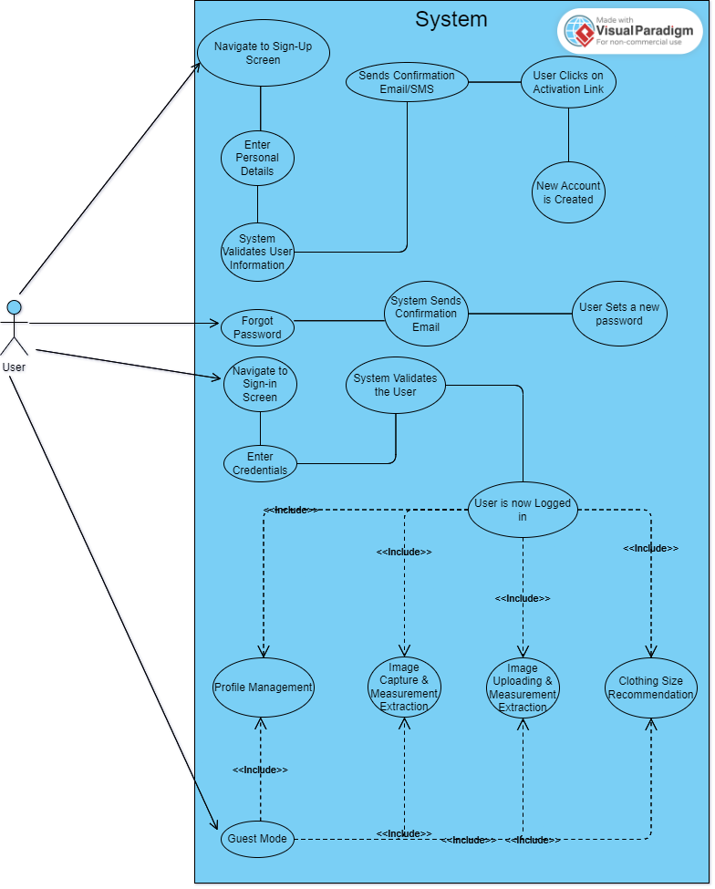

### Profile Management

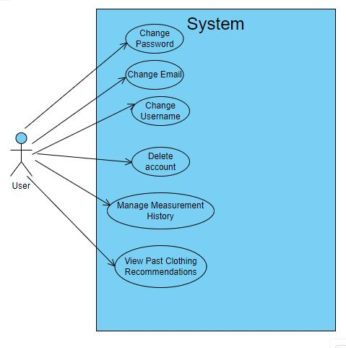

### Image Uploading and Measurement

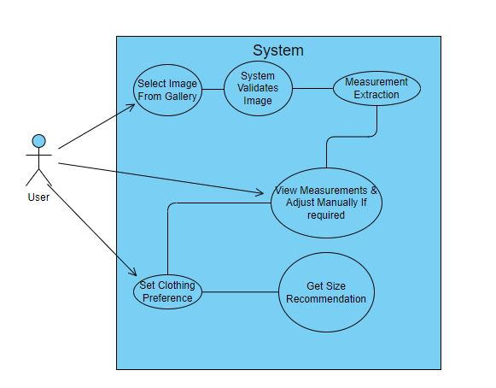

### Image Capturing

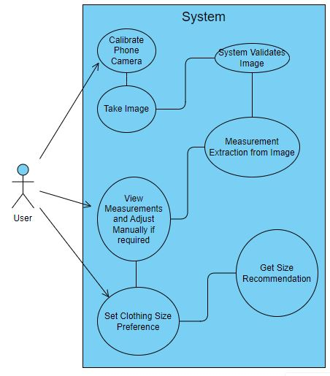

### Clothing Size Recommendations

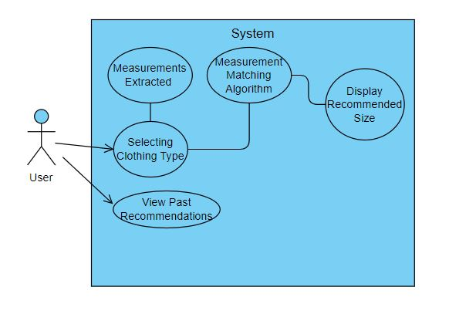

## Software development life cycle model

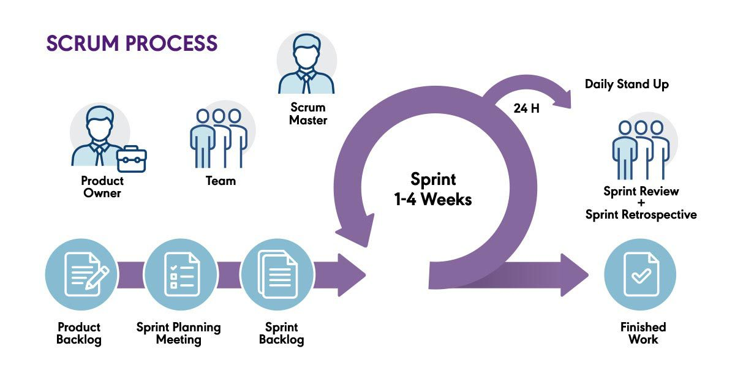

Figure 1 Software Development Life Cycle

Agile methodologies, specifically in our case the Scrum, are particularly well-suited for our project. Scrum enables our development team to work concurrently, ensuring efficient progress across various aspects of the Application. Furthermore, testing is integrated seamlessly into the development process, ensuring that quality assurance is an ongoing endeavor rather than a final step.

Scrum's adaptability is paramount for our project, as image processing and back-end algorithms may change frequently. By prioritizing tasks based on their importance for each iteration, Scrum allows us to deliver valuable increments of the project consistently, thereby enhancing accuracy of the app and a smooth UI.

Regular team meetings are a cornerstone of our Agile approach. These meetings provide opportunities to clarify requirements, test development up to that point, and ensure that the app aligns with initial project goals and objectives.

# System Design

## Work breakdown structure (WBS)

The Work Breakdown Structure (WBS) divides the project into manageable tasks and sub-tasks, ensuring a clear understanding of each phase of development. It provides a hierarchical view of the project components, helping to organize, schedule, and track progress efficiently.

## Activity diagram

### AD01 – Signup

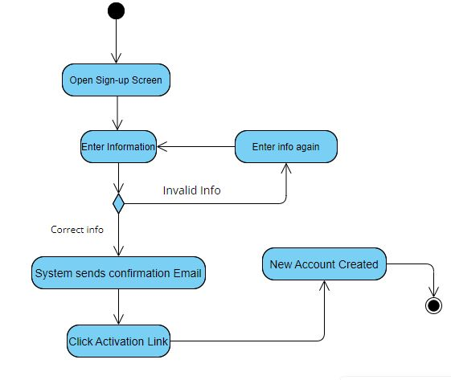

### AD02 – Login

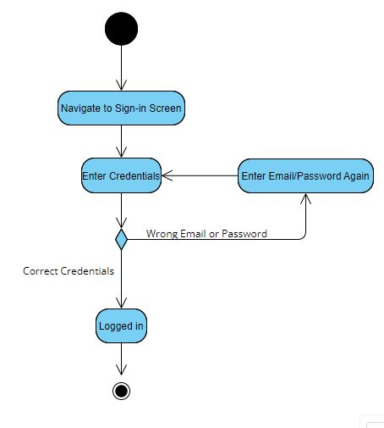

### AD03 – Uploading an Existing Photo

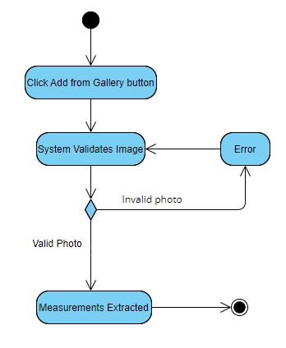

### AD04 – Taking a Photo for Measurement

### AD05 – Getting Clothing Size Recommendation

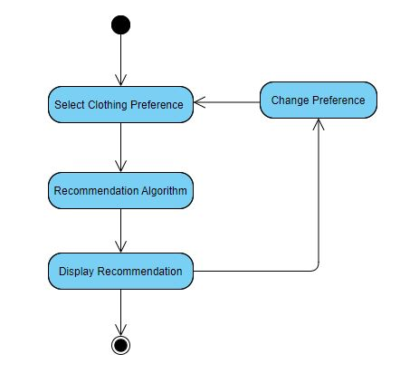

### AD06 – History of Past Measurements & Clothing Size Recommendations

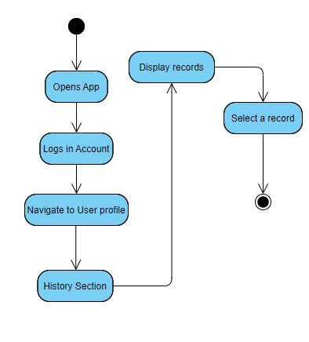

### AD07 – Database management

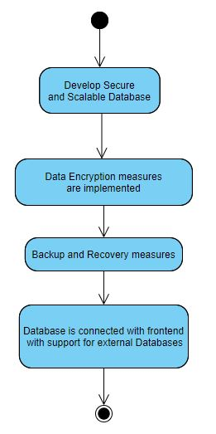

## Sequence diagram

### SD01 – Sign up

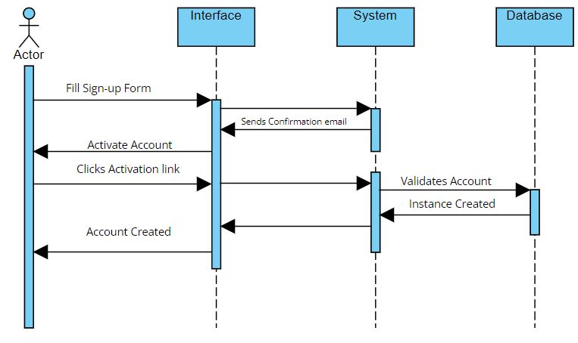

### SD02 – Login

### SD03 – Taking a Photo for measurement

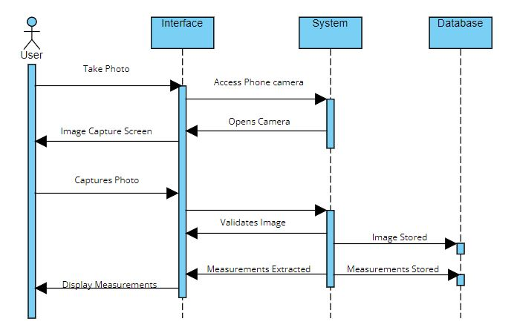

### SD04 – Uploading Photo for measurement

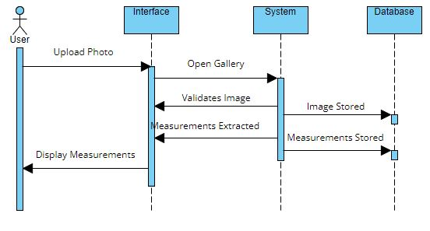

### SD05 – Clothing Size Recommendation

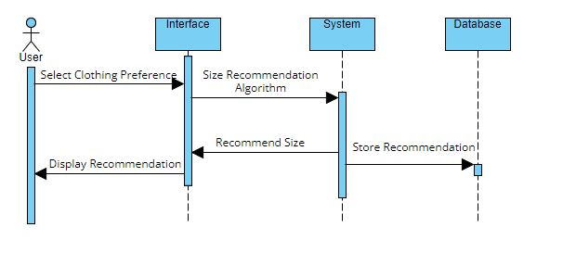

### SD06 – User Feedback

## Software architecture

Client-Side UI/UX will be made through **React-Native**. Which has been chosen for its cross-platform compatibility (IOS and Android).

Python Model will be executed in the Backend layer to manage core functionalities, such as measuring user inputs and storing measurement data. The backend can be developed using **FastAPI** or other frameworks.

A SQL based database management system, like **PostgreSQL**,etc, can be used for building a Database. It will store critical user data, such as body measurements, user profiles, etc.

The application can be deployed in a cloud environment, such as **AWS** or **Google Cloud**, etc. It can also be deployed on a local machine for demonstration. The backend can be hosted using **Gunicorn** to manage the FastAPI application. **Docker** can be used for containerization.

## Class diagram

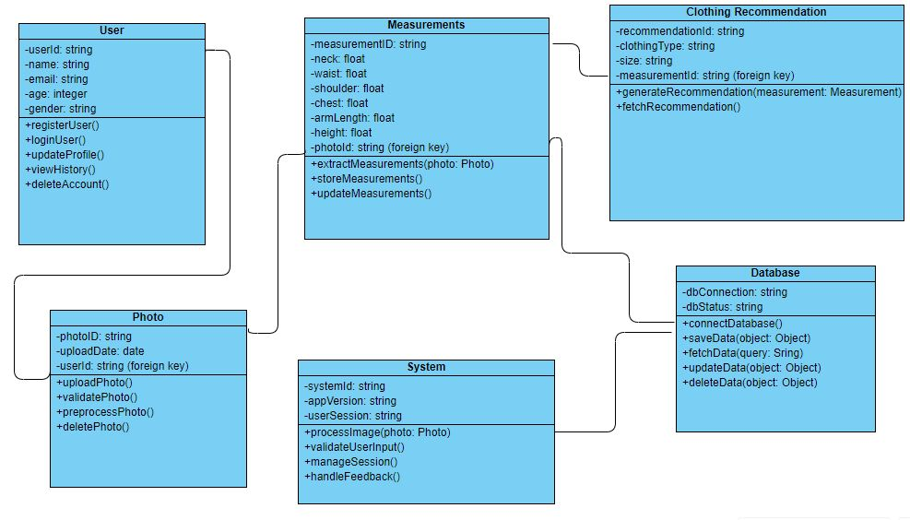

## Database diagram

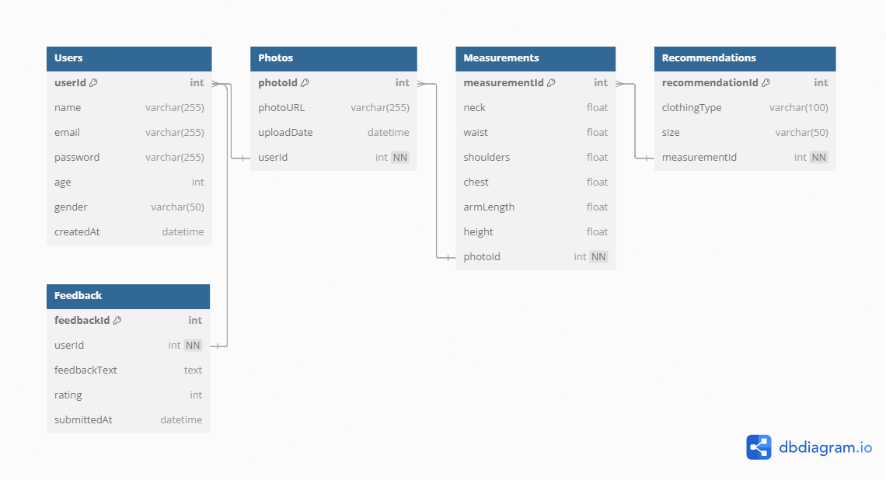

## Network diagram (Gantt chart)

### Network diagram

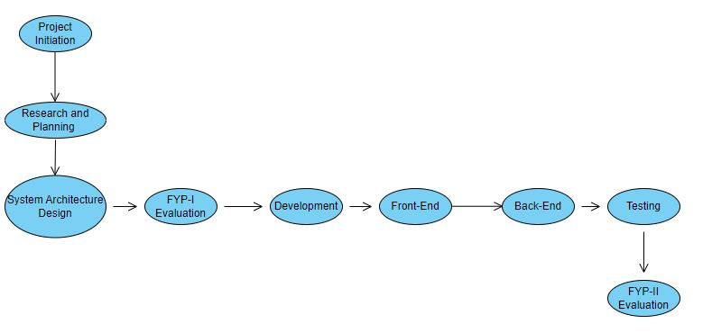

### Gantt Chart

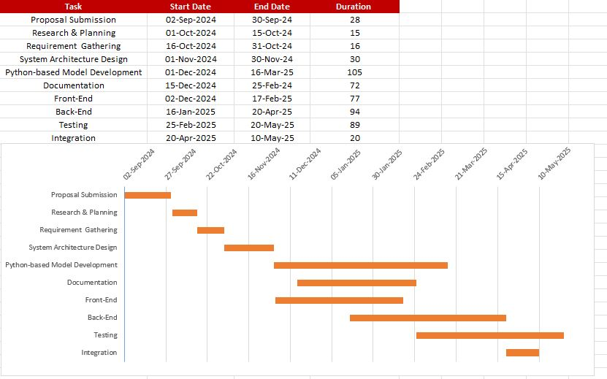

## Collaboration diagram

### Login

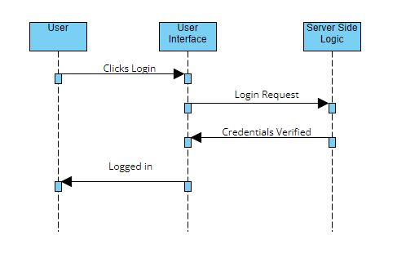

### Reset Password

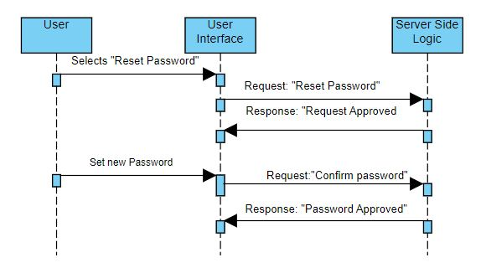

### Upload Picture for Measurement

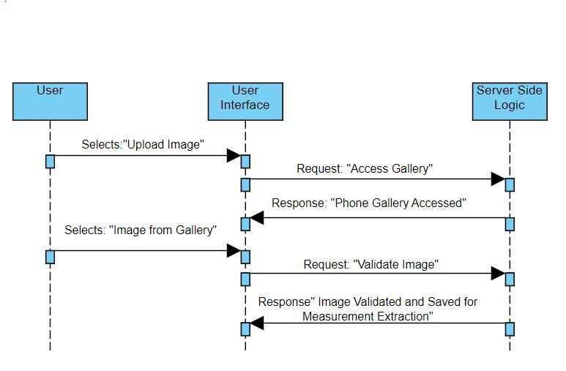

### Take Picture for Measurement

### Clothing Size Recommendation

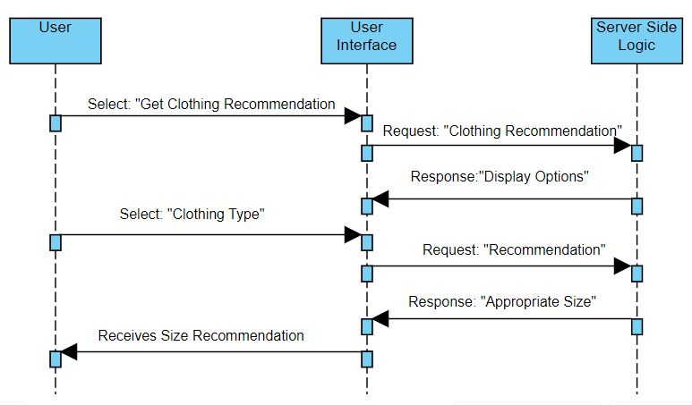

### Get History of Past Measurements and Recommendations

# System Testing

## Test cases

### Login

|  |  |  |  |  |  |  |
| --- | --- | --- | --- | --- | --- | --- |
| **Test Case ID** | **Name** | **Description** | **Test Steps** | **Expected Result** | **Actual Result** | **Pass/Fail** |
| TC01 | Valid Credentials | Verify that the User/Admin can login in valid Credentials. | 1. User navigates to login screen. 2. Enters correct email and password. 3. Taps login button. | The User is successfully logged in. |  |  |
| TC02 | Invalid Credentials | Ensure User cannot log in with Invalid Credentials. | 1. User navigates to the login page. 2. Enters incorrect email or password. 3. Taps on the login button. | The app displays an error message, and the login fails. |  |  |

### Update Profile

|  |  |  |  |  |  |  |
| --- | --- | --- | --- | --- | --- | --- |
| **Test Case ID** | **Name** | **Description** | **Test Steps** | **Expected Result** | **Actual Result** | **Pass/Fail** |
| TC03 | Update User Details | Verify that the user can update user details like age, gender, etc. | 1. User taps on user profile icon.  2. User updates details like age, gender, etc | The user successfully changed details |  |  |

### Reset Password

|  |  |  |  |  |  |  |
| --- | --- | --- | --- | --- | --- | --- |
| **Test Case ID** | **Name** | **Description** | **Test Steps** | **Expected Result** | **Actual Result** | **Pass/Fail** |
| TC04 | Reset Password | Verify that the user can reset their password. | 1. User taps on user profile icon.  2. User taps on reset password button.  3. User sets a new password | The user successfully sets a new password. |  |  |

### User Interface

|  |  |  |  |  |  |  |
| --- | --- | --- | --- | --- | --- | --- |
| **Test Case ID** | **Name** | **Description** | **Test Steps** | **Expected Result** | **Actual Result** | **Pass/Fail** |
| TC05 | Intuitive and User-Friendly Interface | Verify that the user interface is user-friendly and easy to use | 1. Users access the interface.  2. Navigates easily through different modules and functionalities. | User interface is intuitive and user-friendly. Navigation and interaction are easy. |  |  |
| TC06 | Responsive Interface | Verify that the interface is responsive to user interaction | 1. Users access the interface  2. Verify responsiveness of the app. | User interface is responsive and provides a consistent user experience. |  |  |

### View Past Measurements and Clothing Size Recommendations

|  |  |  |  |  |  |  |
| --- | --- | --- | --- | --- | --- | --- |
| **Test Case ID** | **Name** | **Description** | **Test Steps** | **Expected Result** | **Actual Result** | **Pass/Fail** |
| TC07 | View Past Records | Verify that the user can view past records such as measurements and clothing size recommendations | 1. Users log into their account.  2. Navigate to user profile by tapping the user profile icon.  3. Tap view past records button  4. Can view list of past records and open a single record to view details | User can easily view past measurement and clothing size recommendations. |  |  |

### Image Upload

|  |  |  |  |  |  |  |
| --- | --- | --- | --- | --- | --- | --- |
| **Test Case ID** | **Name** | **Description** | **Test Steps** | **Expected Result** | **Actual Result** | **Pass/Fail** |
| TC08 | Image Upload | Verify that the app allows the user to upload images from their gallery | 1. User log into their account.  2. Navigates to upload from gallery screen  3. User uploads image from gallery for measurement extraction, after its validated by the app. | User can upload image from gallery for measurement extraction. |  |  |

### Image Validation

|  |  |  |  |  |  |  |
| --- | --- | --- | --- | --- | --- | --- |
| **Test Case ID** | **Name** | **Description** | **Test Steps** | **Expected Result** | **Actual Result** | **Pass/Fail** |
| TC09 | Image Validation | Ensure that the app performs Image Validation successfully | 1. User log into their account.  2. Navigates to upload from gallery screen or capture image screen  3. User uploads or captures an image | App successfully  Validates correct images for further processing. |  |  |

### Image Capture

|  |  |  |  |  |  |  |
| --- | --- | --- | --- | --- | --- | --- |
| **Test Case ID** | **Name** | **Description** | **Test Steps** | **Expected Result** | **Actual Result** | **Pass/Fail** |
| TC10 | Image Capture | Verify that the app allows the user to capture images from their phone camera for measurement extraction. | 1. User log into their account.  2. Navigates to capture image screen  3. User captures an image using phone camera. | User is able to successfully capture an image via phone camera. |  |  |

### Measurement Extraction

|  |  |  |  |  |  |  |
| --- | --- | --- | --- | --- | --- | --- |
| **Test Case ID** | **Name** | **Description** | **Test Steps** | **Expected Result** | **Actual Result** | **Pass/Fail** |
| TC11 | Measurement Extraction | Verify that the app successfully extractions measurements from user uploaded/captured images with minimal error. | 1. User log into their account.  2. Navigates to upload from gallery screen or image capture screen.  3.User uploads/captures an image for measurement extraction. | The app successfully extractions accurate measurements with minimal error. |  |  |

### Manual Measurement Adjustment

|  |  |  |  |  |  |  |
| --- | --- | --- | --- | --- | --- | --- |
| **Test Case ID** | **Name** | **Description** | **Test Steps** | **Expected Result** | **Actual Result** | **Pass/Fail** |
| TC12 | Manual Measurement Adjustment | Verify that the app allows the user manually adjust measurements after they are extracted | 1. User log into their account.  2. Navigates to upload from gallery screen or image capture screen.  3.User uploads/captures an image for measurement extraction.  4. User can adjust the extracted measurements. | User is successfully able to adjust measurements after they extracted. |  |  |

### Clothing Size Recommendation

|  |  |  |  |  |  |  |
| --- | --- | --- | --- | --- | --- | --- |
| **Test Case ID** | **Name** | **Description** | **Test Steps** | **Expected Result** | **Actual Result** | **Pass/Fail** |
| TC13 | Clothing Size Recommendation | Verify that the app gives users correct clothing size recommendation based on measurements and preferred clothing type. | 1. User log into their account.  2. Navigates to upload from gallery screen or image capture screen.  3.User uploads/captures an image for measurement extraction.  4. User selects clothing preference.  5. App generates appropriate size recommendation for selected clothing. | The app successfully generates correct clothing size recommendations. |  |  |

### Database Management

|  |  |  |  |  |  |  |
| --- | --- | --- | --- | --- | --- | --- |
| **Test Case ID** | **Name** | **Description** | **Test Steps** | **Expected Result** | **Actual Result** | **Pass/Fail** |
| TC14 | Store and retrieve user data | Verify that the database can store and retrieve user data efficiently. | 1. Register a new user, upload/capture images, extract measurements, get size recommendations  2. Check database to ensure all of these are stored securely in the database  3. View past user records to check if database can efficiently retrieve data. | Data is stored and retrieved efficiently and reliably. |  |  |

## Unit

To verify and ensure that each component of the app works and operates as intended, unit testing will be performed. Individual components such as image validation, measurement extraction, and size recommendation will be tested.

## Integration

Integration testing will be performed to ensure that the modules function as intended when integrated with each other. Components such as image capture/upload should work when integrated with image validation. Moreover, we will test interactions between components like frontend and backend, application and the database. For example, backend should process uploaded/captured images correctly and store measurements in the database successfully.

## Acceptance testing

In acceptance testing we will test to see if the app fulfils the project requirements. We will test whether Users are able to get correct measurements and clothing size recommendations with minimal error. During this testing phase it will be ensured that the flow of events: upload/capture image, extract measurements and receive clothing size recommendation, happen without issues or errors. Users must have a seamless UI experience and navigation between different modules and functionalities is intuitive and easy.

# Conclusion

This section highlights the challenges encountered during development, and discusses the lessons learned. It also outlines potential future work and enhancements to improve the application.

## Problems faced and lessons learned

We faced problems in the following areas of development:

1. Image processing accuracy.
2. Database Integration.
3. User Interface Design.
4. Time Constraints.

Following are the lessons we learned during development:

1. Importance of Modular Design. Breaking the project down into smaller manageable components in the beginning is key to better development, debugging and testing.
2. Iterative testing must be done during development to identify issues early on the development phase. Particularly with image processing and data storage.
3. Incorporating user feedback about the UI during development enhances the app’s usability and smooth.
4. Effective Time management is essential to development. We have to prioritise tasks, use scheduling and employ regiment of work.

## Project summary

The **TailoMe** project aims to revolutionize the tailoring and clothing shopping experience by providing an accurate body measurement application. It uses advanced image processing techniques and Python-based backend algorithms. The app extracts body measurements, such as neck, waist, shoulders, chest, height, and arm length, directly from user-uploaded or captured photos. The application also offers personalized clothing size recommendations based on these measurements on different clothing types including traditional desi and western attire.

Key features include image validation, measurement extraction, user profile management, and a smooth user interface for capturing and uploading images. The project integrates backend database management for securely storing user data, measurement history, and clothing preferences.

## Future work

Following is the future work that we aim to do on the application:

### Enhance Features

* + - 1. Posture detection: Posture analysis to further improve measurement accuracy.
      2. Integration with Clothing Stores: Collaborating with online retailers to redirect users to their website after a size prediction on a particular type of clothing.
      3. Measurement Prediction: Use machine learning to predict missing measurements.

### Platform Expansion

Developing a web-based version of the application.

### Scalability

Leverage cloud services for scalability, fast processing and responsiveness.

# References

[1]***Z. Cao, G. Hidalgo, T. Simon, S.-E. Wei, and Y. Sheikh,***"OpenPose: Realtime Multi-Person 2D Pose Estimation Using Part Affinity Fields," *IEEE Transactions on Pattern Analysis and Machine Intelligence, vol. 43, no. 2, pp. 172-186, 2018. [Online]. Available:*[*https://arxiv.org/pdf/1812.08008.pdf*](https://arxiv.org/pdf/1812.08008.pdf)*.*

[2]***Mirrorsize****. "Ultimate Body-Measuring App for Perfectly Fitting Clothes." [Online]. Available:*[*https://www.mirrorsize.com/blogs/ultimate-body-measuring-app-for-perfectly-fitting-clothes*](https://www.mirrorsize.com/blogs/ultimate-body-measuring-app-for-perfectly-fitting-clothes)*.*

[3]***3DLOOK****.* "3DLOOK" *[Online]. Available:*[*https://3dlook.ai/content-hub/3dlook-is-a-member-of-the-mobile-body-scanning-standards-developed-by-ieee/*](https://3dlook.ai/content-hub/3dlook-is-a-member-of-the-mobile-body-scanning-standards-developed-by-ieee/)*.*

[4]***Bodymapp.*** *"3D Body Scanning App | Health and Fitness Tracker." [Online]. Available:*[*https://bodymapp.co*](https://bodymapp.co/)*.*

[5] ***Kristijan Bartol, David Bojanić, Tomislav Petković, Tomislav Pribanic,****"A Review of Body Measurement Using 3D Scanning," ResearchGate, 2022. [Online].* Available: <https://www.researchgate.net/publication/351207865_A_Review_of_Body_Measurement_Using_3D_Scanning>.

[6] ***M. Montazerian and L. LEYMARIE,****"Measuring the Human Body from a Single Camera," Semantic Scholar, 2022. [Online]. Available:*[*https://www.semanticscholar.org/paper/Measuring-the-Human-Body-from-a-Single-Camera%2C-with-Montazerian-LEYMARIE/ae8c70ec2e5fe71f7692f51a9f7527f173d46f41?utm_source=direct_link*](https://www.semanticscholar.org/paper/Measuring-the-Human-Body-from-a-Single-Camera%2C-with-Montazerian-LEYMARIE/ae8c70ec2e5fe71f7692f51a9f7527f173d46f41?utm_source=direct_link)*.*

[7] ***University of London,****"Designing a Contactless AI System to Measure the Human Body using a Single Camera for the Clothing and Fashion Industry," ResearchGate, 2023. [Online]. Available:*[*https://www.researchgate.net/publication/373343443_Designing_a_Contactless_AI_System_to_Measure_the_Human_Body_using_a_Single_Camera_for_the_Clothing_and_Fashion_Industry*](https://www.researchgate.net/publication/373343443_Designing_a_Contactless_AI_System_to_Measure_the_Human_Body_using_a_Single_Camera_for_the_Clothing_and_Fashion_Industry)

[8] ***A. Sehgal and A. Gupta,****"Automatic Extraction of 3D Body Measurements from 2D Images," Semantic Scholar, 2022.*

Appendix A

*Include here the 1st page of Turnitin Report*

Every supervisor has his/her own Turnitin account. If not then the supervisors are requested to get the account from Library as soon as possible.